ELLEN SCHMITT
VICE CHAIR
JOSEPH ROGAN
CHAIR

City of Jacksonville

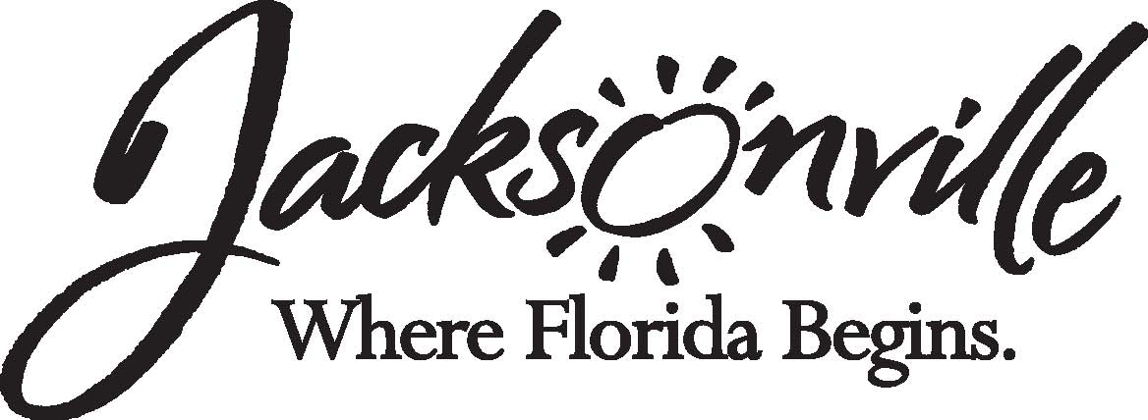

IMANI A. BOYKIN
GEORGE CANDLER
CARLTON DEVOOGHT
J. J. DIXON

ETHICS COMMISSION
DARCY GALNOR
LATONYA LIPSCOMB SMITH
MARY BLAND LOVE

RESOLUTION OF THE JACKSONVILLE ETHICS COMMISSION
February 3, 2020

WHEREAS, the Jacksonville Ethics Commission has a duty under sections 602.911 and 602.921 of the Jacksonville Ordinance Code and under section 1.202(d) of the Charter of the City of Jacksonville to “recommend changes in legislation to City Council in the areas of ethics laws and administration, conflicts of interests, hotline policies, ethics education, ethics in procurement, campaign ethics, and lobbying”; and

WHEREAS, in connection with such duties, the Jacksonville Ethics Commission has reviewed the Jacksonville Ethics Code, section 602.1205, and discussed potential changes to same;

BE IT RESOLVED, by the Jacksonville Ethics Commission, as follows:

- That the Jacksonville Ethics Commission recommends the attached amendments to section 602.1205 of the Jacksonville Ordnance Code, per section 1.202(d) of the Charter of the City of Jacksonville.

- That the Jacksonville Ethics Commission hereby submits the attached legislation to the City Council, per section 3.106 of the Jacksonville Ordinance Code.

- That this resolution shall become effective upon execution on this 3rd day of February, 2020.

BY: ____see original for signature___________________________________
Joseph Rogan, Chair

WITNESS: ______see original for signature_________________________________
Kirby Oberdorfer, Deputy Ethics Director

Vote (1/22/20): In Favor: 8 Opposed: 0

