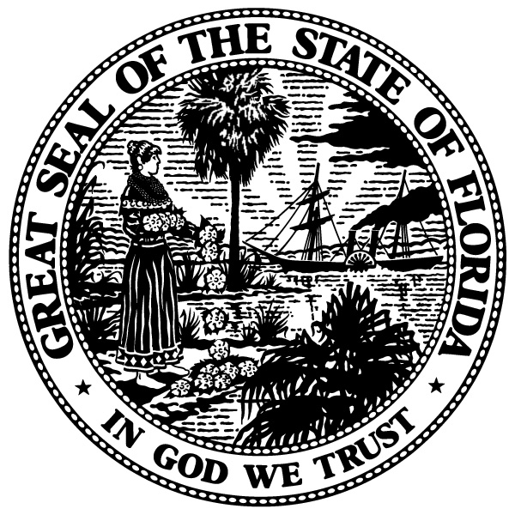

Duval County

SENATORS
AARON BEAN
AUDREY GIBSON

REPRESENTATIVES
CORD BYRD
KIMBERLY DANIELS
TRACIE DAVIS
WYMAN DUGGAN
JASON FISCHER
CLAY YARBOROUGH
Legislative Delegation

CHAIR
REPRESENTATIVE JASON FISCHER

VICE CHAIR
REPRESENTATIVE KIMBERLY DANIELS

2019 PUBLIC HEARING
APPEARANCE RECORD

P L E A S E P R I N T

Please complete and email to lvoellmecke@coj.net. If you do not receive a response within 4 days, please call the delegation office at (904) 255-5105. This form and all materials for the meeting must be received by October 25, 2019.

Name of Speaker:

Contact Person:

Name of Organization:

Address:

City: Zip:

Phone: Type: Cell Office Home

E-mail:

Please select: Proponent Opponent Information
Do you have handouts? Yes No

Comments/request:

PLEASE COMPLETE AND RETURN TO DELEGATION COORDINATOR. PURSUANT TO ARTICLE I, SECTION 24 OF THE FLORIDA CONSTITUTION, THIS DOCUMENT, AND THE INFORMATION CONTAINED THEREIN, IS A PUBLIC RECORD.

